This document intends to ease communication on ideas for improvement or questions that might be too long to be discussed in the frame of WhatsApp exchange.
For instance, a point that would require much follow up with OW with exchange of data and that can be used later for continuous improvement or training purposes could be captured here.

Question 1 Correction in the documentation
Question 2 : Total Efficiency calculation
Question 3 : PVC cycle explanation
Question 4 : Maintenance SLA
Question 5 : Most used plastics conversion rate

Question 1 Correction in the documentation

Technical

In the below picture the liters and tons show the same value.

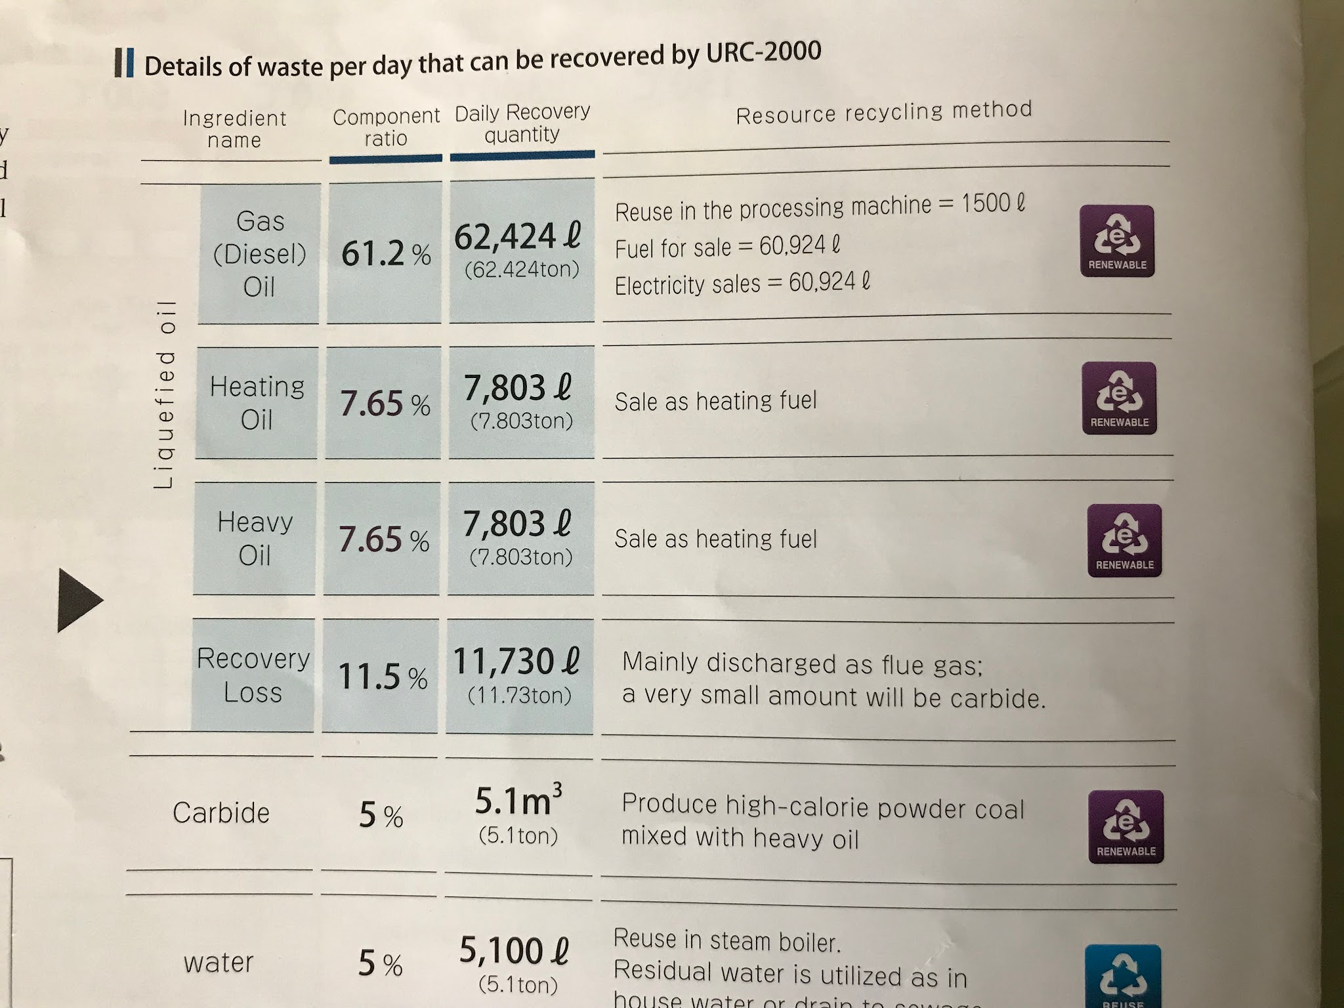

This can only be true if the specific gravity of all products is 1.
This might be a detail, but engineers will pick it up and might start questioning other points.
To increase the trust of customers first reading the information I suggest it is changed in the PDF version.

Question 2 : Total Efficiency calculation

Technical

Form the brochure, we know that Urban rigs have a recovery rate of about 85%.
This is the same regardeless of the model.
This is also based on a resin content of 90% with a density of 0.6.
since most plastics have a density superior to 1 (https://omnexus.specialchem.com/polymer-properties/properties/density ), can we imagine having a shredding / compacting apparel to increase the density?
Would that increase the efficiency or would it require too much time to heat the load, and be counterproductive ?

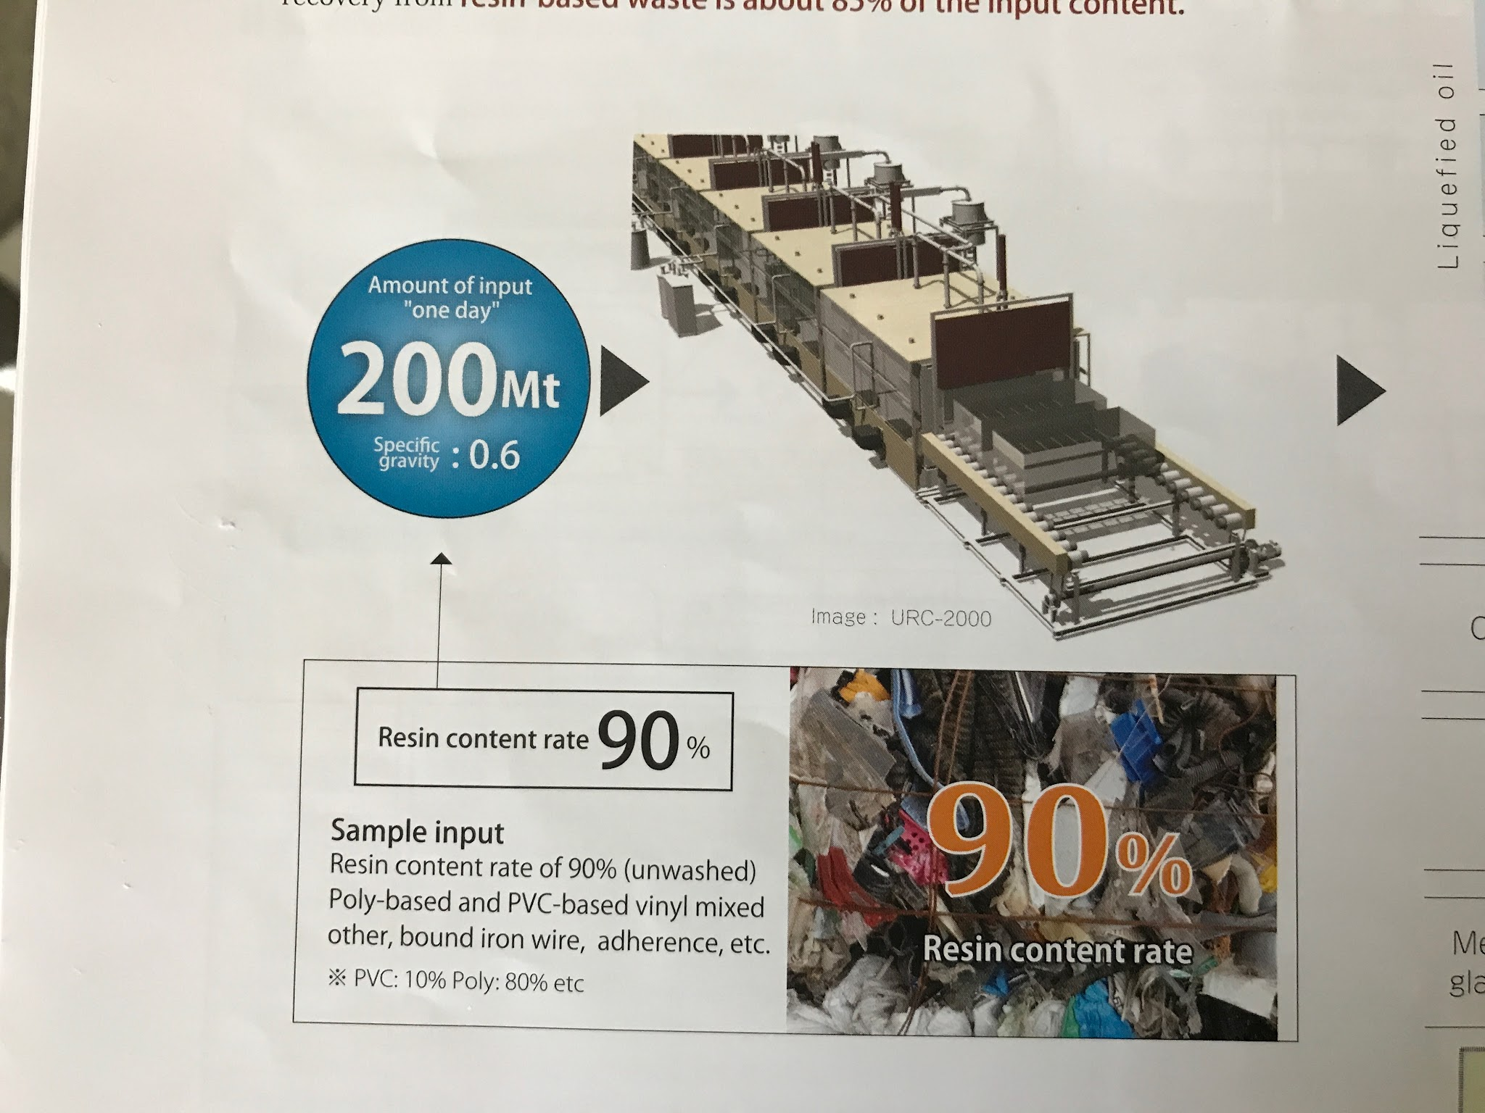

Question 3 : PVC cycle explanation

Technical

I know that was discussed during the meeting but I would love to have a detailed explanation of what happens when PVC is treated in the Urban Rig.

My understanding is that:
- As no combustion occurs, no Dioxin is released.
- I also understand from the conversation that the Chlorine was not present in the Oils generated.
- I believe there is something happening in the catalytic layer, and if I interpret correctly Mr Ito hand gestures, it seems to me that the Chlorine is “falling back” in the furnace.
- If the above is correct, I think the chlorine can either :
  - Be in the resulting Charcoal in case of mixed waste being treated.
  - Be in the char for the pure PVC loads?
  - Remain on the chamber’s wall?

In the case of a) => can the Charcoal be later burned or will it release Dioxin and should be otherwise disposed of.
In the case of c) should the equipment walls be cleaned to avoid potential contamination of further loads or is that not happening?

Any explanation of what happens in detail is greatly appreciated here.

Question 4 : Maintenance SLA

Commercial

Can you described what are the SLA when the customer opted for full insurance, menaing he is ready to pay an extra 7% on top of the equipment price for total peace of mind.

Question 5 : Most used plastics conversion rate

Technical

Can you check / comment the highlighted numbers>
I want to make sure the conversion rate is approximately the same regardless of plastic type.
Also the PVC point is redundant with question 3

Typical plastic mix Europe | low % | High % | conversion rate | Potential issue
Polyethylene (PE) | 20% | 25% | 90% | No
Polypropylene (PP) | 15% | 20% | 90% | no
Polyethylene Terephthalate (PET) | 10% | 15% | 90% | no
Polystyrene (PS) | 5% | 10% | 90% | No
Polyvinyl Chloride (PVC) | 0% | 5% | 90% | Potentially in by products
Polycarbonate (PC) | 0% | 5% | 90% | No
Other Plastics | 20% | 25% | 90% | ???

Question 6 : Advantages of using steam

Technical

As I am drafting a competition map in Europe, I have notice that a number of competitor offer plastic hydrolysis.
It is however “dry” hydrolysis with no mention of heat being used and apparently requiring

